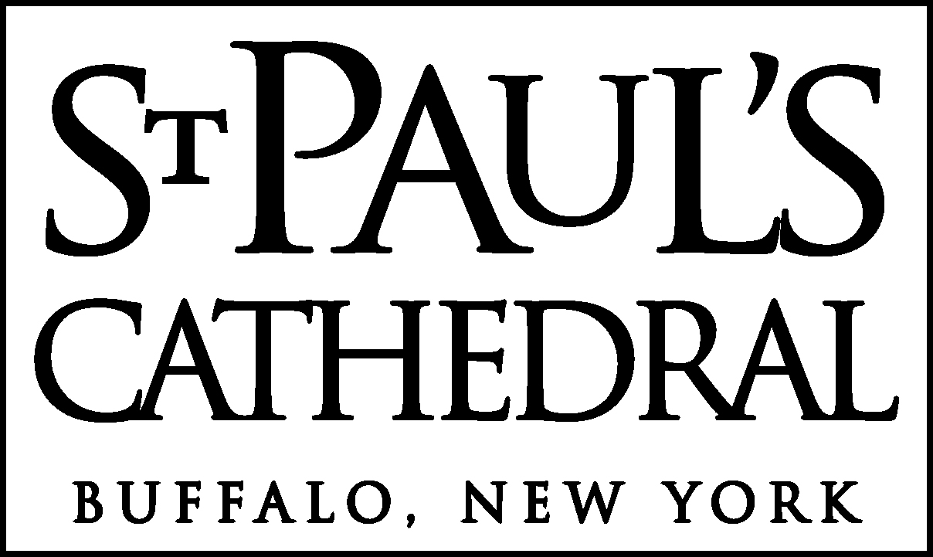

The Blessing & Dedication
of the
Mordecai Noah Marker

June 3, 2012



The Very Rev. N. DeLiza Spangler, Officiant
The Rev. Donald M. Huber, Cathedral Canon Vicar
Mr. Jerry Klinger, President of Jewish American Society for Historic Preservation
Mr. Wayne Mori, Archivist for St. Paul’s Cathedral

The Choir of Men and Girls

Mr. Jonathan Scarozza, Cathedral Organist & Choirmaster
Ms. Abigail Rockwood, Assistant Cathedral Organist & Choirmaster

St. Paul’s Cathedral offers hospitality, healing, and hope
in the name of Jesus Christ
in the city of Buffalo and the Episcopal Diocese of Western New York.
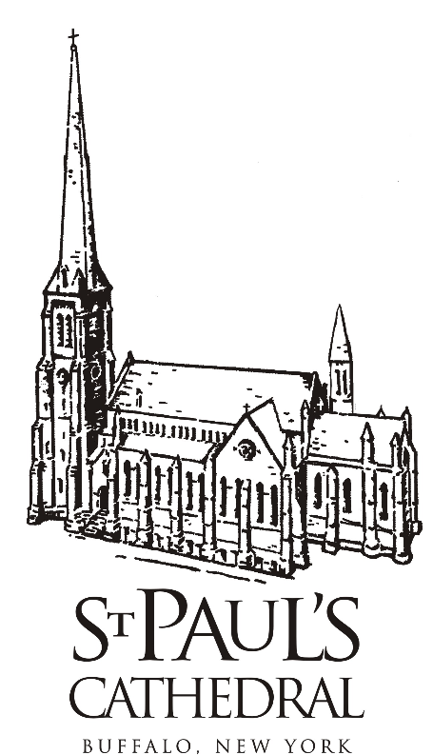

The Blessing and Dedication of the
Mordecai Noah Marker

A Gift from the Jewish American Society for Historic Preservation (JASHP)

After the Choral Voluntary, the Choir, Clergy and Congregation will process to the marker
The Processional Anthem
“O pray for the peace of Jerusalem” Herbert Howells (1892-1983)
O pray for the peace of Jerusalem. They shall prosper that love thee. Peace be within thy walls, and plenteousness within thy palaces. (Psalm 122: 6, 7)

Mr. Jerry Klinger, President, on behalf of the Jewish American Society for Historic Preservation
On behalf of the Jewish American Society for Historic Preservation, I present this historic marker to be dedicated to the glory of Almighty God and for the edification of all who read it.

Dean Spangler, on behalf of St. Paul’s Cathedral
St. Paul’s Cathedral gratefully accepts this gift as a sacred trust, and we will maintain it with care as a remembrance of the Rev. Addison Searle and Major Mordecai Noah.

Unveiling of the Marker

Dean Let us pray
People Eternal God, the Creator and Lover of all peoples, we praise you for
all who have labored for liberty, justice and peace on earth, and
especially for your servants Addison and Mordecai, who we honor this
day. Grant that their devotion and zeal of long ago may bring forth good
fruit even in this generation and in the generations to come. And may we,
encouraged by their example, go into the world as instruments of peace.
Amen.
The Litany for Peace

Canon Vicar O God, the Creator and Preserver of all humankind, who made us in your own
image, grant us compassion toward the whole human family
People Hear our prayer and make us instruments of your peace.

Canon Vicar Take away the arrogance, hatred and suspicion that infect our hearts
People Hear our prayer and make us instruments of your peace.

Canon Vicar Break down the walls that separate us
People Hear our prayer and make us instruments of your peace.

Canon Vicar Unite us in bonds of love
People Hear our prayer and make us instruments of your peace.

Canon Vicar Work through our struggle and confusion to accomplish your reign on earth
People Hear our prayer and make us instruments of your peace.

Canon Vicar Grant that, in your good time, all nations and races may serve you in harmony
People Hear our prayer and make us instruments of your peace.

The Blessing and Dedication for the Marker

Dean Let us pray
Almighty God, bless this marker which we dedicate to you this day, for the
adornment of this park and the inspiration of all who pass by. May this
memorial be an enduring witness before all people of the faithful service of
your servants Mordecai and Addition. And grant that we, encouraged by their
deeds, may follow their good example of mutual respect and concern for others.
Amen.

Guest Comments
Remarks by Mr. Jerry Klinger, President of the Jewish American Society for the Historic Preservation

Guest Comments
Remarks by Mr. Wayne Mori, Archivist of St. Paul’s Cathedral

The Dean then says
The Benedication
The Lord bless you, and keep you.
The Lord make his face to shine upon you, and be gracious unto you:
The Lord lift up his countenance upon you, and give you peace. Amen.

The Episcopal Diocese of Western New York

The Rt. Rev. Dr. R. William Franklin, Diocesan Bishop

www.rwilliamfranklin.org/ & jerusalem-crossing.com/

rwfranklin@episcopalwny.org 881-0660

Cathedral Chapter
The Very Rev. N. DeLiza Spangler, Cathedral Dean
dean@spcbuffalo.org 855-0900 ext. 225
The Rev. Donald M. Huber, Cathedral Canon Vicar
canon@spcbuffalo.org 855-0900 ext. 226
The Rev. Jason Rayburg-Elliott, Cathedral Deacon Precentor
deacon_jason@spcbuffalo.org 855-0900 ext. 231
The Rev. Kim Greene, Cathedral Deacon
deacon_kim@spcbuffalo.org 855-0900
Mr. Jonathan Scarozza, Cathedral Organist-Choirmaster
jonathan@spcbuffalo.org 855-0900 ext. 227
Ms. Abigail Rockwood, Cathedral Assistant Organist-Choirmaster
abigail@spcbuffalo.org 855-0900 ext. 228

Cathedral Staff
Ms. Chris Luehrsen, Administrator
office@spcbuffalo.org 855-0900 ext. 222
Ms. Diane Zawadzki, Accountant
diane@spcbuffalo.org 855-0900 ext. 230
Mr. Nicholas Buster, Senior Sexton
570-7133
Ms. Eleanor Bender, Sexton
ellie@spcbuffalo.org 570-7132
Ms. Kathy Reiss, Mr. Eli Holden,
Ms. Vivian Huang, Ms. Becky Keenan
Nursery Attendants
855-0900 ext. 247

Cathedral Vestry
Dr. Reid Heffner, Warden
Ms. Cheryl Fisher, Warden
Mr. Michael Bonilla – Finance & 20s/30s
Mr. Charles Casto – Hunger-Outreach
Ms. Diane Cumbo - Music
Ms. Denise Doherty – Adult Education
Ms. Kelly Giordano – Parish Life
Ms. Hannah Holden - Investments
Mr. James Kipler – Pastoral Care
Ms. Sue Nealon - Newcomers
Mr. Donald Ogilvie - Communications
Ms. Anne Simet - Properties

www.stpaulscathedral.org
Vestry minutes & agendas: www.spcbuffalo.org
Liturgical calendar: www.spcbuffalo.org
Vestry mailbox: vestry@spcbuffalo.org
facebook.com/pages/Buffalo-NY/St-Pauls-Episcopal-Cathedral-Buffalo/266777903698
ST. PAUL’S CATHEDRAL, 128 PEARL STREET, BUFFALO, NY 14202

