Adolph Sutro – Mayor of San Francisco
The Missing Word
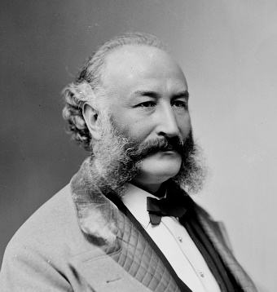
Adolph Sutro was the 24th Mayor of San Francisco, 1894-1896. He was a Jewish-American immigrant from Germany, a brilliant mining engineer, entrepreneur, real estate developer, art and literary collector. Sutro was a self-made millionaire who made his first fortune in Nevada’s Comstock silver boom, constructing the famed Sutro Tunnel outside Virginia City. In Nevada, but especially in San Francisco, he lived his life with an overriding public concern for the little guy in society.
He had no love for the rich that paraded in San Francisco and squeezed the working class. If anything, he was contemptuous of those with money who did not use their wealth for the betterment of all. Justifiably, he was revered by the working class of the city that voted him in to be their Mayor on the Populist ticket.
“I don’t believe in aristocracy (Sutro said). The aristocracy of the mind is the only aristocracy I recognize. It makes no difference to me whether a man has not got a cent or whether he is a millionaire. On the contrary, when a man is wealthy, I am more suspicious of him than I am of a poor man. I have found it in my experience that rich men, as a general thing, lose a great deal of the better feeling which they had when they were poor.”
Sutro used his great wealth for the public good. He did not forget his Jewish identity.
A campaign biography was written about Sutro in 1895 by Eugenia Kellog Holmes.
“His contributions to all public charity, since his arrival to opulence, have been munificent, and confined neither to race, creed nor class. His private alms are said to be limited only to the immediate needs of the individual.”
San Francisco has numerous recognitions and honors named for him, Mount Sutro, Sutro Railway, Sutro Baths, Sutro Library, Sutro Heights, sculptures, busts, the Cliff House, and even an elementary school. The Golden Gate National Recreation Park and the National Park Service have numerous interpretive markers about his gifts and public efforts in the Lands End (Point Lobos) area of San Francisco, which they designated as the Sutro Historic District. The District is noted for its breathtaking views of the Pacific, the Seal Rocks, and a magnificent park he created for all San Franciscans at his own expense.
In all the honors and recognitions for Adolph Sutro, one word was missing, the word Jew.
Sutro accomplished what he did because he was the best, the ablest to do what he did. He never campaigned or sought honors or position, using his ethnicity or “race” as a PR cudgel crying antisemitism.
Jews were called “Hebrews” until after WWII. They were considered a separate and distinct race in America. The Holocaust brought racial identity and antisemitism to shame and a hoped-for permanent death. Regretfully, that death has risen Phoenix-like anew from the ashes in the last few years.
Jewish historical legitimacy, commonality, and contributions as Americans have rapidly come under delegitimization again. False vilifications by shallowly educated demagogues have emerged.
2020-2021, the San Francisco School Board was roiled by Woke political activists demanding that San Francisco schools named for those they deemed racists, sexists, or were “injustice linked” be renamed immediately. Forty-four Schools were seriously considered by the School Board for renaming as over-riding priorities during the deep darkness of the Pandemic. Among the schools they demanded be renamed were Abraham Lincoln, George Washington, Thomas Jefferson, Robert Louis Stevenson, Paul Revere, Senator Diane Feinstein, others, and, of course, Adolph Sutro.
The half-educated crusaders cursorily included Sutro for his alleged racism. Sutro had built a “wonder of the world” public bath next to his famous Cliff House for the public of San Francisco to come and enjoy. In 1897 a Black man attempted to gain admission to the Baths. He was denied entry to the swimming pools. The management of the Sutro Baths did not permit Blacks.
Sutro Baths were sued and, directly, intentionally, Sutro himself.
The problem was that Sutro no longer managed the Sutro Baths. His son did and set the policy. The racially discriminatory act that barred Blacks from the Baths was not done by Adolph Sutro. There had never been an instance in Sutro’s life of discrimination against Blacks before.
Sutro had turned over the management of the Baths to his son because he was rapidly declining into dementia. The lawsuit against Sutro and the Baths was filed just a few months before his death in 1898. Sutro was far from aware of the situation, the racial injustice, that had occurred. He, by that time, had to have a guardian appointed for his affairs because he was incompetent.
The Woke zealots of the San Francisco School Board attacked a man who had given all to San Francisco for an incident he had nothing to do with and would have handled differently if he was able.
The national publicity and disgrace that descended upon the San Francisco School Board and the City forced the politically expedient response. They tabled the motion for a later date.
The Jewish American Society for Historic Preservation (JASHP) has recognized the growing delegitimization of the American Jewish experience by the neo-antisemites and its destructive effects on America. JASHP, doing what no other Jewish organization has or is doing, has placed historical markers, memorials, pavers, and more, in 40 States and in six countries. The projects specifically recognize the American Jewish story and its contributions to America.
Sometimes it only takes the inclusion of a single word to broaden the appreciation of American diversity and uniqueness, the word Jew.
JASHP contacted the Golden Gate National Recreational Park and the National Park Service, asking if their markers recognized the first openly Jewish Mayor of San Francisco, Adolph Sutro. None did.
However, the Parks were in the process of updating and replacing the badly worn old historical interpretive markers in the Lands End area that reflected on Sutro. The bad, none of the new markers again identified him as the first Jew to be elected Mayor of San Francisco. But, if JASHP was willing to pay for a new marker, they would consider doing one noting the overlooked, important fact of his ethnicity.
JASHP agreed and paid.
The new marker was recently installed outside the entrance to the Sutro Heights park overlooking the Pacific. A short and simple sentence was added, “This was the estate of Adolph Sutro—a Jewish-American immigrant, mining engineer, and Mayor of San Francisco.”
To our knowledge, this is the only marker or memorial in San Francisco, a city Sutro deeply loved, that recognizes he was a Jew.
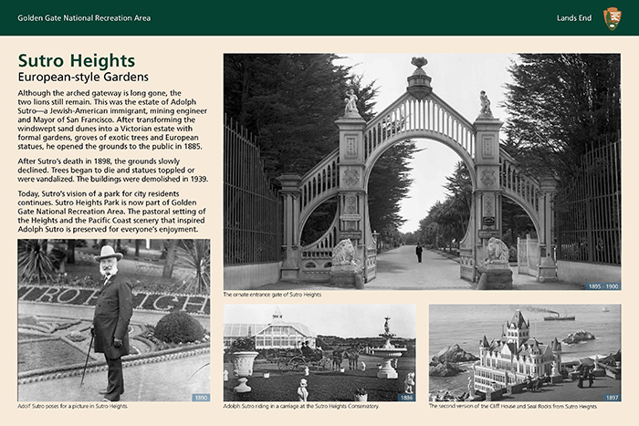
https://www.hmdb.org/m.asp?m=202194
Jerry Klinger is the President of the Jewish American Society for Historic Preservation.
www.JASHP.org

