**Mount Zion celebrates tradition, looks to future in state**

Pioneering congregation marks 160 years in state.

**By**[**Jean Hopfensperger**](http://www.startribune.com/jean-hopfensperger/10645071/) Star Tribune

**MAY 7, 2017 — 9:35PM**

[[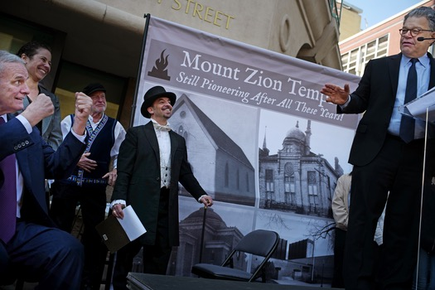](http://stmedia.startribune.com/images/Zion.JPG)](http://stmedia.startribune.com/images/Zion.JPG)

RICHARD TSONG-TAATARII, STAR TRIBUNESenator Al Franken, right, joked with Governor Mark Dayton about him being a gentile at the site of the original Mount Zion Temple. In the center is Rabbi Adam Stock Spiker.

Rabbi Adam Stock Spilker doesn’t typically sport 19th-century clothing. But on Sunday, members of his Mount Zion temple celebrated a historic anniversary for Minnesota’s Jewish community — the 1856 founding of Mount Zion as the state’s first Jewish congregation.

Born before Minnesota was a state, Mount Zion put Minnesota on the map for the early waves of Jewish immigrants to the Midwest and laid the foundation for a community of about 45,000 today.

|  |
| --- |
|  |

Over the years, the temple evolved from integrating European newcomers steeped in ancient Jewish tradition to serving a more secular community steeped in 21st-century life.

“In the late 1800s, we were making Jews modern,” said Spilker. “Now we’re making modern people Jews.”

Gov. Mark Dayton and U.S. Sen. Al Franken were among the well-wishers speaking at the anniversary celebration Sunday at a street fair at the temple’s original home in downtown St. Paul. Folks in 19th-century dress circulated through the crowd, while children were introduced to simple games their great-grandparents may have played.

Mount Zion wasn’t the only Minnesota Jewish pioneer. In 1878, a congregation now known as Temple Israel put down roots in Minneapolis. Jews in St. Paul, however, faced less discrimination, historians say. Whether it was due to Jews’ early landing in St. Paul or the community itself, Mount Zion’s pioneers were able to integrate into community life.

“Henry Sibley [Minnesota’s first governor] contributed money to building our temple,” said Mary Ann Wark, a Mount Zion historian, mingling with the crowd. “There was a Yiddish section of the St. Paul public library in 1901.”

“It’s important to remember that Jews have always been part of St. Paul,” she said. “That’s why we celebrate this anniversary.”

**Street fair marks progress**

If Sunday’s street fair had been held in the 19th century, the women in long dresses and men in top hats would belong to ethnic Jewish families, embracing the traditional faith, living close enough to the temple that they could walk to worship.

“Intermarriage would be a German Jew marrying a Russian Jew,” joked Spilker.

Today, Jewish-Christian couples are common in the congregation, said Spilker. And membership is diverse by race and sexual orientation. Members drive to the synagogue on Summit Avenue from across the Twin Cities and even Wisconsin. And many people identify more closely with Jewish culture and community than with its religious beliefs, said Spilker.

“The challenge is, how can we acculturate and maintain our own tradition, and also bring it to the modern era?” he said. “How do we offer a sense of place, space and grounding in a way connected to our ancient traditions?”

Over the years, Mount Zion has worked to meld the past with the present. It hasn’t been without controversy. In 1903, for example, it allowed women full membership. In 1984, its assistant Rabbi Stacy Offner became the first female rabbi in Minnesota. However, her tenure ended a few years later when Offner came out as a lesbian and left the congregation under pressure.

**Focus on social justice**

In the 1980s, it launched dialogues with the black community. Today those dialogues are occurring with Twin Cities’ Muslims.

Mount Zion is active in other interfaith collaborations, said Spilker, including a century-old friendship with Gloria Dei Lutheran Church, founded on the same street corner in downtown St. Paul more than 160 years ago. And the temple’s former senior rabbi, Leigh Lerner, conducted the first interfaith wedding in the Twin Cities in 1977 — to the dismay of many Jewish leaders.

Like any congregation, Mount Zion has gone through hills and valleys. But a constant has been an emphasis on reform and social justice, said Spilker. Longtime member Harry Lippman recalled going on a youth trip to impoverished Spanish Harlem in the 1960s and still can’t shake the image of rats scurrying in and out of tenement buildings.

“It changed my life,” he said. “You learn it’s important to identify with anyone experiencing discrimination.”

Nancy Brady, president of Neighborhood House in St. Paul, was among Sunday’s speakers. Neighborhood House, a social-service anchor on St. Paul’s West Side, was founded by women from Mount Zion in 1897 to assist a wave of East European Jewish immigrants. Members of the congregation have continued to volunteer their time, donations and expertise to helping the Neighborhood House, which now supports immigrants from around the globe.

“Nothing at the Neighborhood House is done alone,” Brady told the crowd.

The Jewish American Society for Historic Preservation used the occasion to unveil a memorial plaque at the site of Mount Zion’s first home at the corner of 10th and Minnesota streets.

Robin Doroshow, executive director of the Jewish Historical Society of the Upper Midwest, said all four of her grandparents immigrated to St. Paul in the early 1900s and benefited from Mount Zion’s pioneers.

“What is interesting to me about Mount Zion is it was here before the first large wave of [Jewish] immigration from Eastern Europe,” she said. “It paved the way and established the Twin Cities Jewish community in an organized way. It has been and continues to be a stalwart leader for social justice in both the Jewish and general communities.”

**http://www.startribune.com/celebrating-160-years-of-jewish-life-in-minnesota/421571443/**